Planning soccer player positioning

# Problem definition

Given the positioning of 11 soccer players from the attacking team and the ball's position, we want to find the defending players' optimal positioning (coordinates, x, y, of 11 players).

We will define optimal positioning according to the following criteria:

* Maximize coverage of pass lines (a)
* Maximize coverage of the goal (b)
* Minimize distance to opponent players (c)
* Maximize pitch control area (d)

Each of these criteria will have a weight [0, 1] associated defined by the user. This weight will indicate the importance that the user gives to a specific criterion.

In our problem, we need to optimize 22 integer values between [0, 100], which correspond to the values of the coordinates of each player.

To optimize these values, we will test the following algorithms:

* Optuna (TPE/CMA-ES method)
* Hill Climbing, Simulated Annealing
* Genetic Algorithms

In the end, we expect to show the results and even some visualizations of the progress made by each algorithm.

a

b

c

d

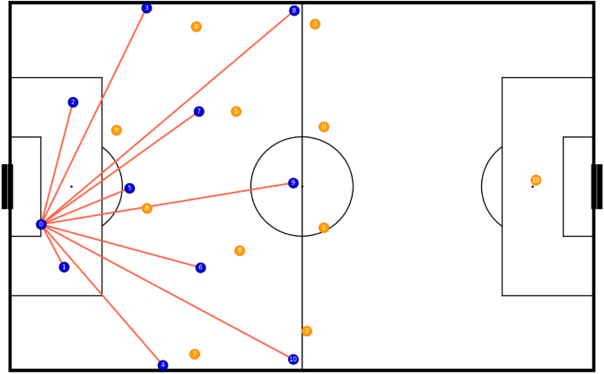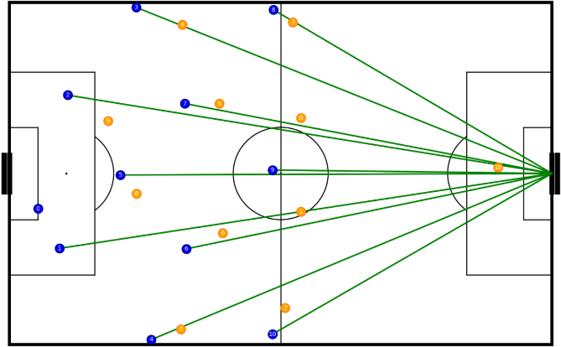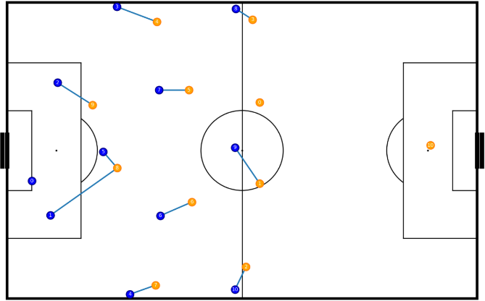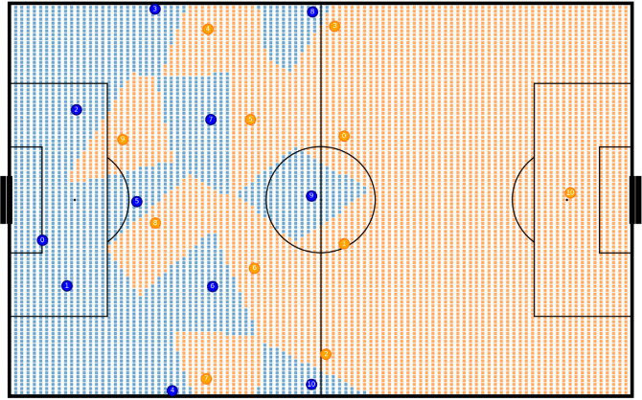Figure 1 – Visualization of the criteria to be optimized. Ball in possession of blue player 0.